Highly Available 3-Tier Web Application on AWS
Project Overview
This project demonstrates the deployment of a highly available, scalable, and secure 3-tier web application on AWS.
The architecture is designed to:
- Handle traffic spikes (auto scaling)
- Ensure high availability (multi-AZ)
- Provide secure access (HTTPS)
- Separate concerns using 3-tier design
Objectives
- Deploy infrastructure across multiple Availability Zones
- Configure Auto Scaling Group (ASG)
- Use Application Load Balancer (ALB) for traffic distribution
- Store static content in S3
- Secure application using HTTPS
- Implement secure access using Bastion Host
- Enable EBS encryption using KMS

Architecture Diagram (Explain in words)
Flow:
User → ALB (HTTPS) → Target Group → EC2 (ASG in Private Subnets)
↓
EBS
↓
S3
→ Access Private EC2

Infrastructure Setup
VPC Configuration
- Created VPC with CIDR: 10.0.0.0/16
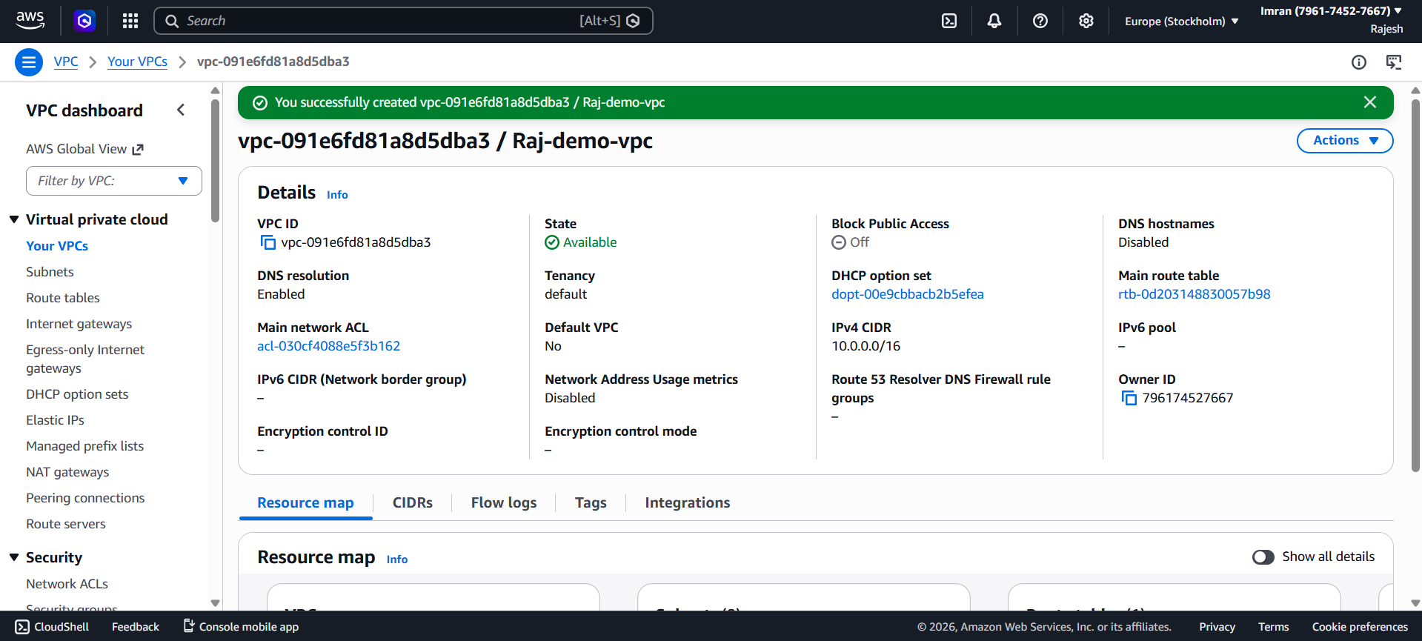

Subnets
- Public Subnets:
- 10.0.1.0/24 (AZ-1a)
- 10.0.2.0/24 (AZ-1b)
- Private Subnets:
- 10.0.3.0/24 (AZ-1a)
- 10.0.4.0/24 (AZ-1b)
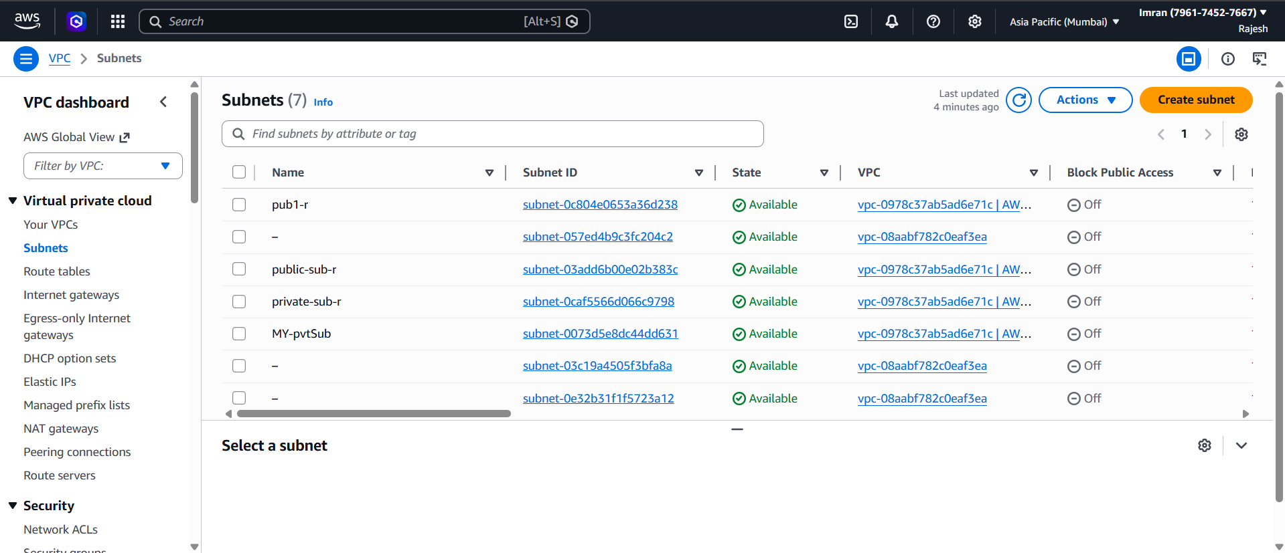
Route Tables
- Public Route Table
- Route: 0.0.0.0/0 → Internet Gateway
- Associated with Public Subnets
- Private Route Table
- Route: 0.0.0.0/0 → NAT Gateway
- Associated with Private Subnets
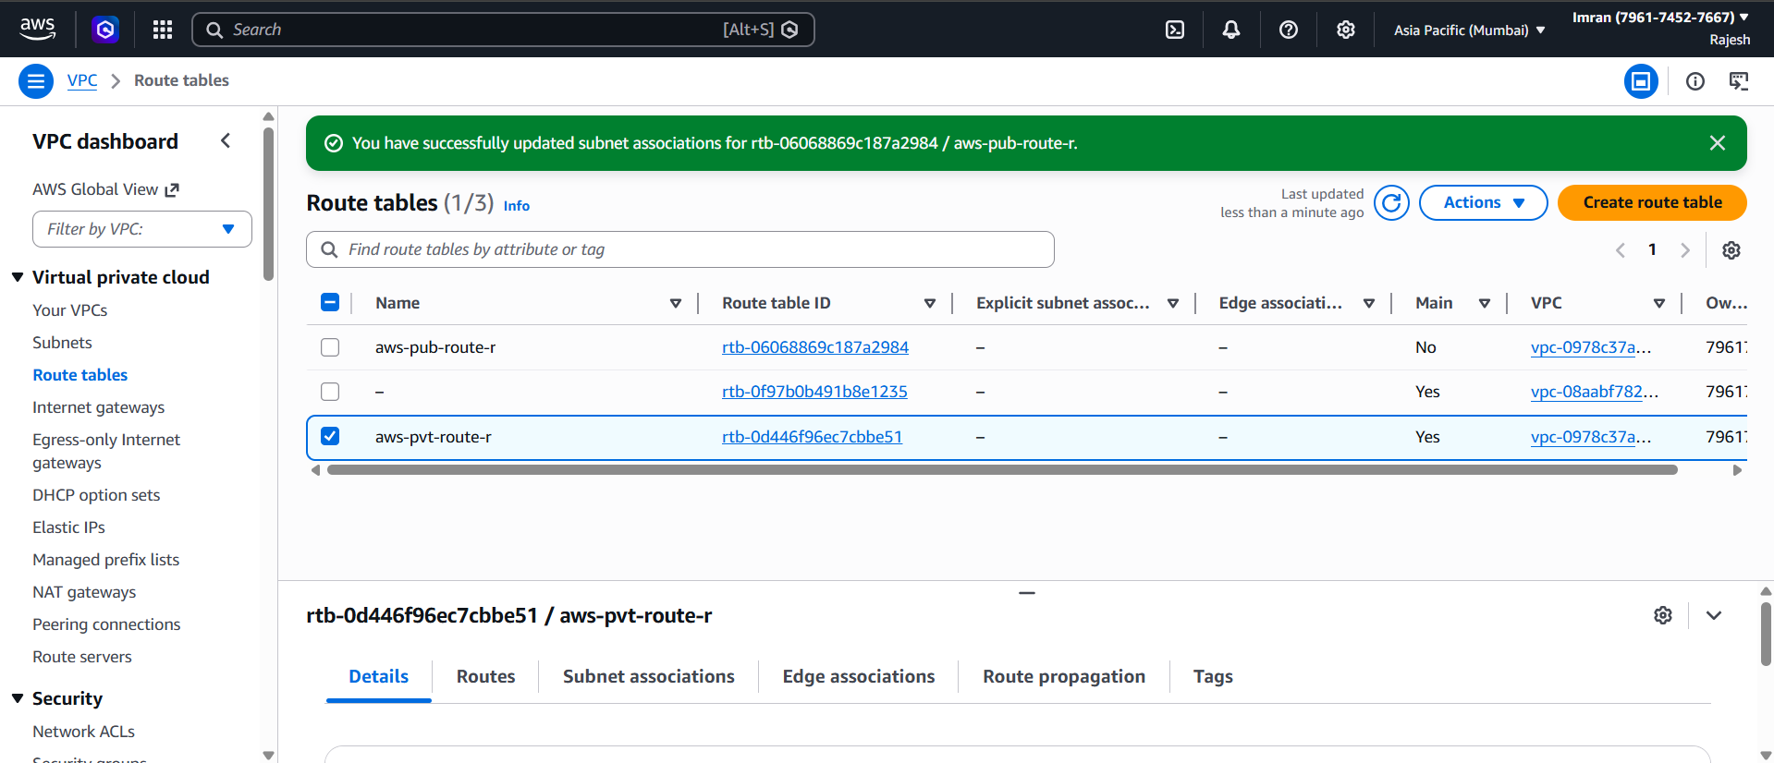
Internet & NAT Setup
- Internet Gateway attached to VPC
- NAT Gateway created in Public Subnet
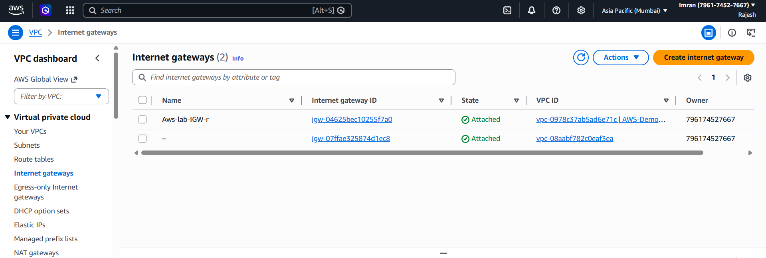
Golden AMI
- Installed Apache/Nginx
- Deployed application code
- Created reusable AMI for consistency
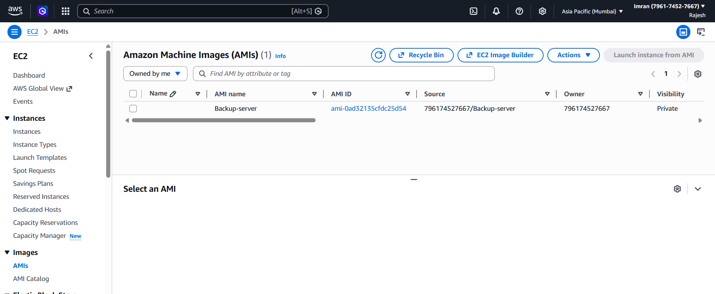

Launch Template
- Instance Type: t3.micro
- AMI: Golden AMI
- Security Group attached
- Configured User Data for automation
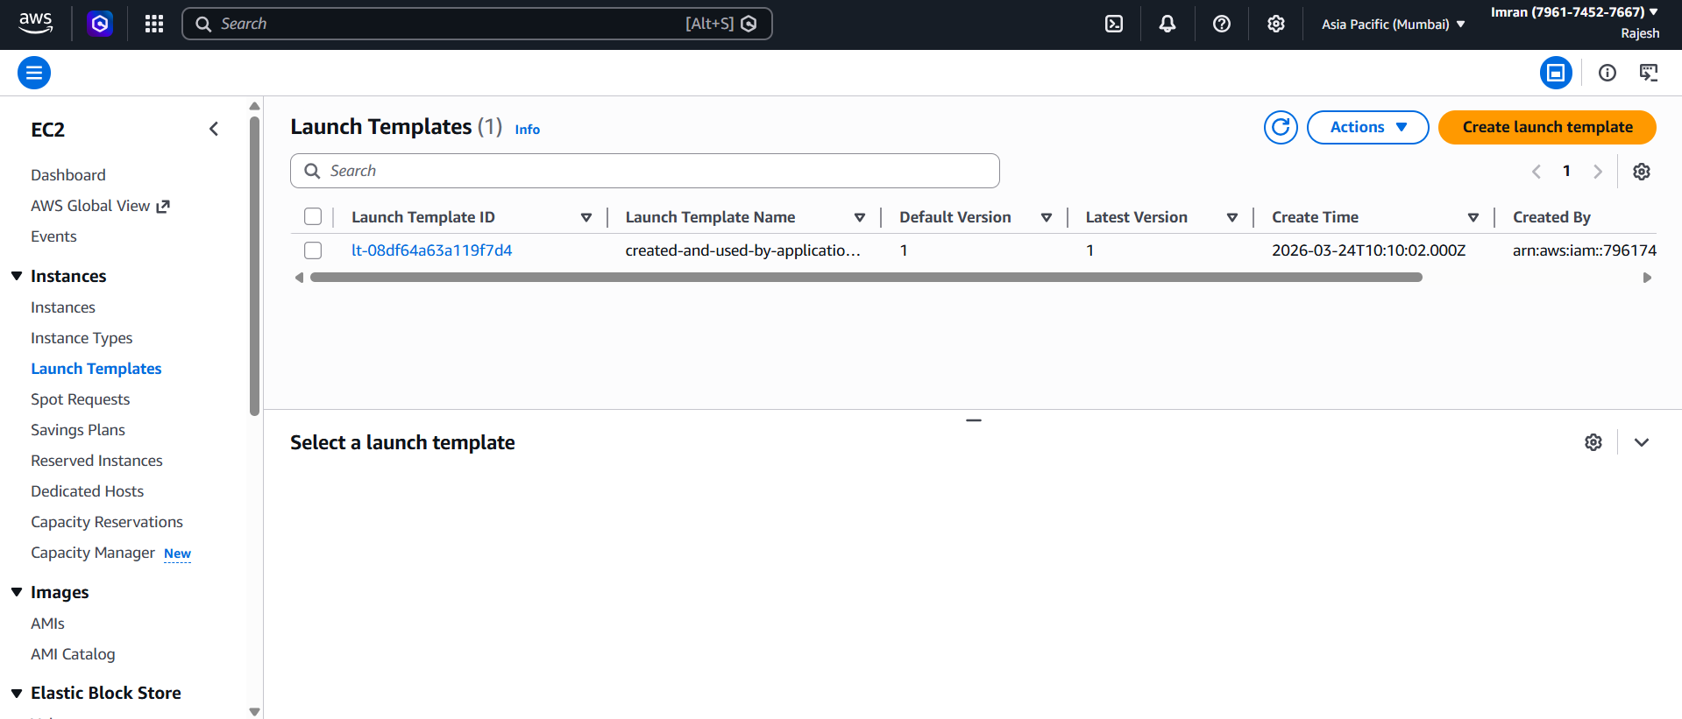

Storage Layer
EBS Configuration
- Volume Type: gp3
- Size: 20 GB
- Encryption enabled using AWS Key Management Service
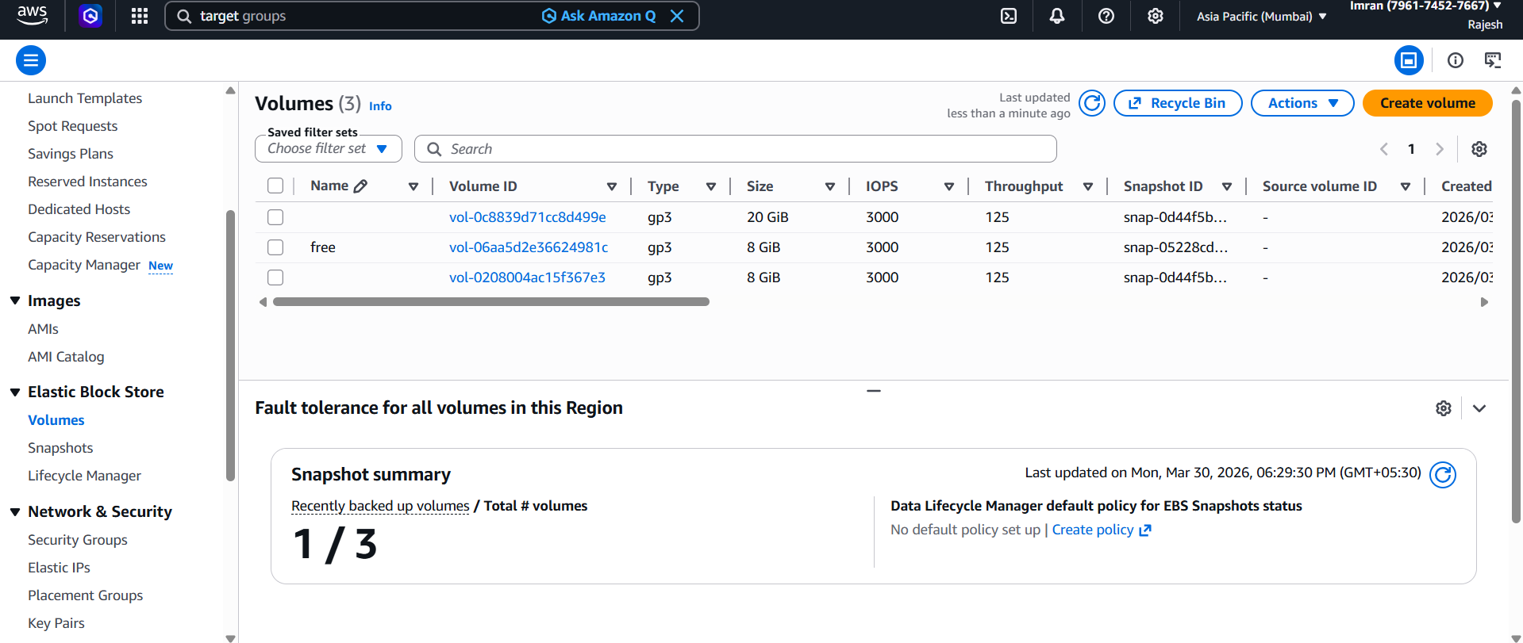
S3 Configuration
Used Amazon S3 for:
- Static files (images, CSS, JS)
Features:
- Versioning enabled
- Highly durable storage
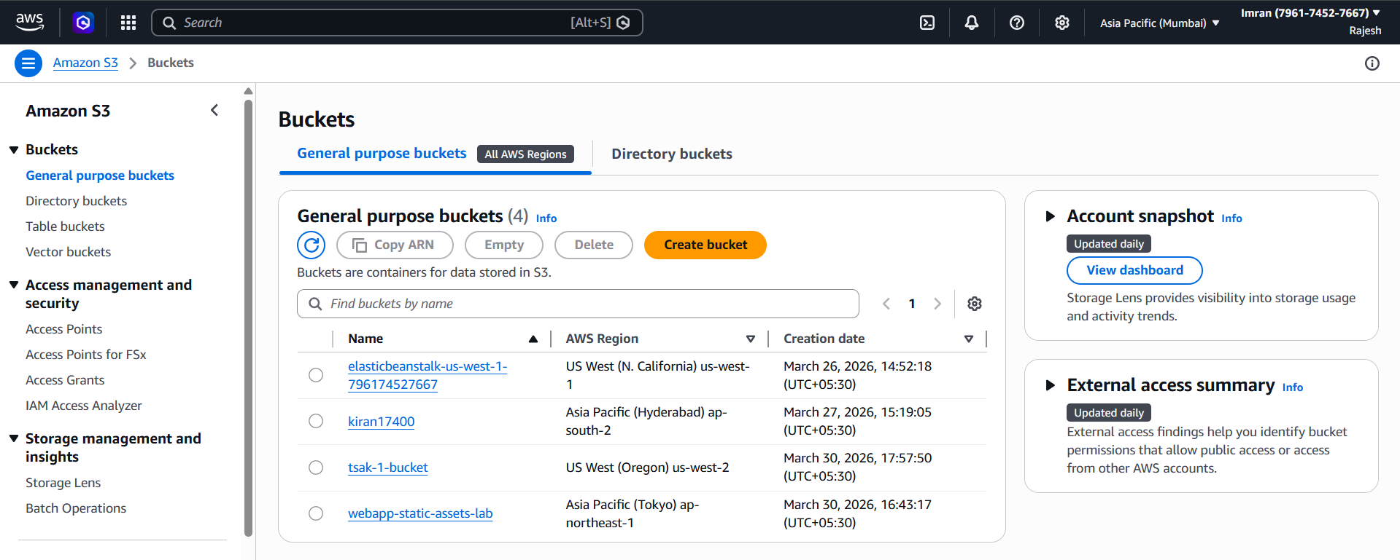

Target Group
- Protocol: HTTP
- Port: 80
- Health checks enabled
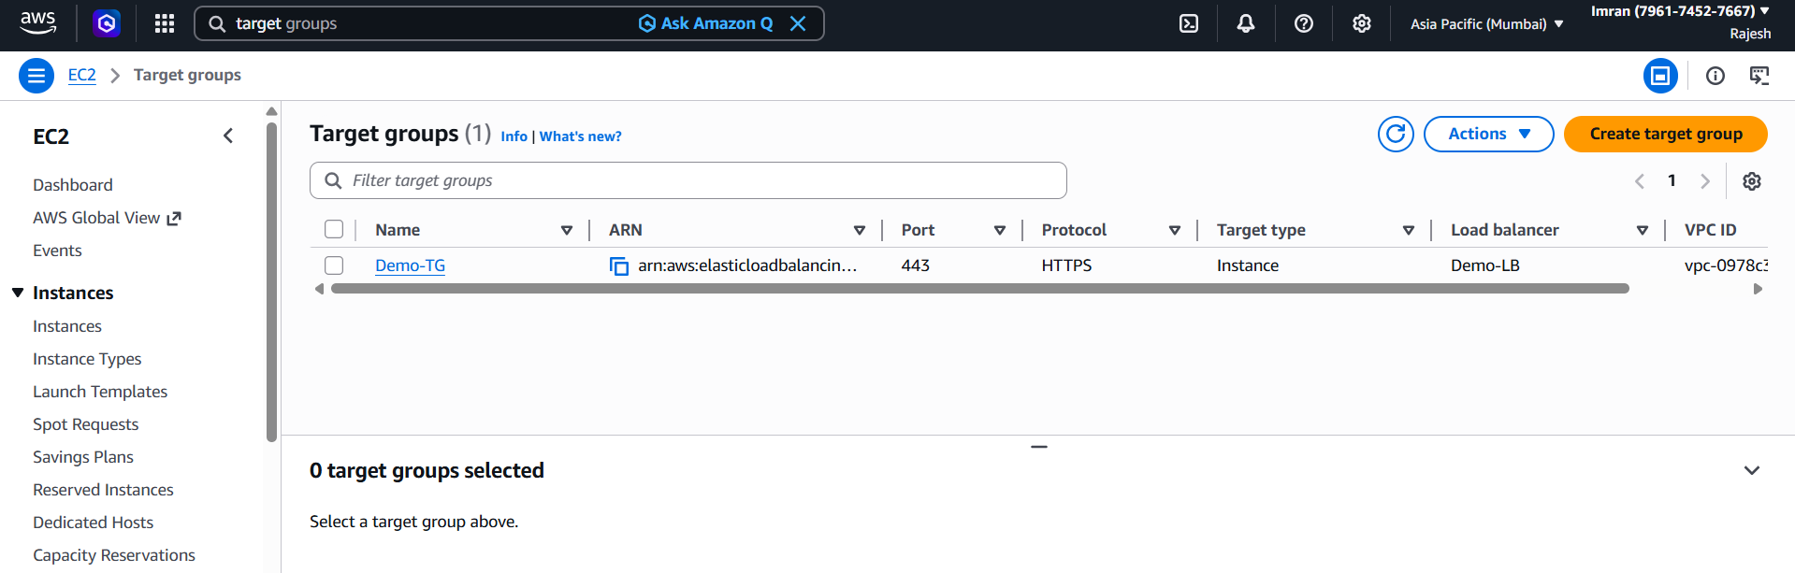

Load Balancer Layer
Application Load Balancer (ALB)
- Type: Internet-facing
- Deployed in Public Subnets
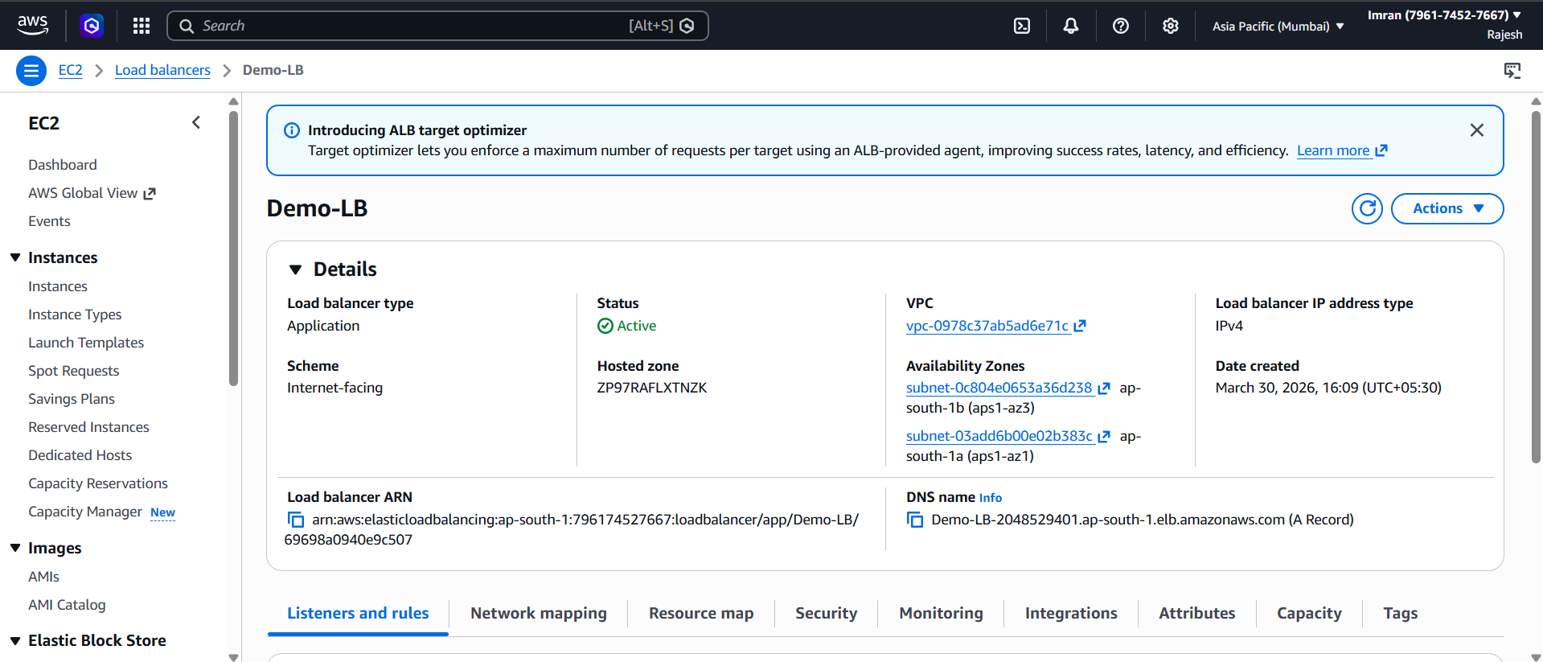
Auto Scaling Group (ASG)
- Min: 2 | Desired: 2 | Max: 4
- Deployed in Private Subnets across 2 AZs
Scaling Policy:
- Target tracking based on CPU utilization (70%)
Features:
- Self-healing (replaces unhealthy instances)
- High availability
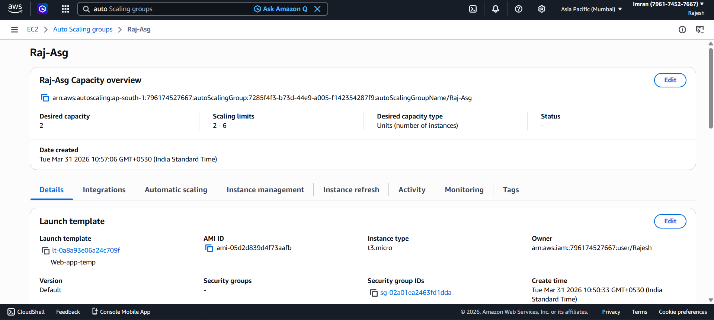

HTTPS Configuration
Used AWS Certificate Manager
- Listener: HTTPS (443)
- SSL certificate attached
Advanced Features
- Cross-Zone Load Balancing enabled
- Sticky Sessions enabled (1 hour)
Security Configuration
Security Groups
ALB SG
- Allow HTTPS (443) from Internet
App Server SG
- Allow HTTP only from ALB SG
Bastion SG
- Allow SSH (22) only from My IP

Access Flow
User → ALB → EC2 (Private)
Admin → Bastion → EC2

Validation & Testing
- Accessed application via ALB DNS

- Verified load balancing across instances
- Tested auto scaling using load
- Terminated instance → ASG recreated it
- Verified HTTPS access

Key Concepts Used
- High Availability (Multi-AZ)
- Auto Scaling
- Load Balancing
- Secure Access (Bastion Host)
- Data Encryption (EBS + KMS)
- Object Storage (S3)
- HTTPS Security

Challenges Faced
(You can customize this section)
Example:
- Incorrect route table association
- Security group misconfiguration
- Target group health check failures

Conclusion
The project successfully demonstrates a scalable, secure, and highly available AWS architecture capable of handling production-level workloads.
It follows best practices like:
- Multi-AZ deployment
- Auto scaling
- Secure networking
- Encrypted storage

